**Name of student: ____Yixin Wang__________ Student ID: ____yw326___**

**NAU + CQUPT: Fall 2020**

**EE 188L Lab 8**

**AC Measurements of a Series Resistor & Capacitor Voltage Output, and of a Series Resistor & Inductor Voltage Output, at Several Frequencies with the Dual-Channel Oscilloscope**

**Summary**

The purpose of this lab is first to demonstrate AC Measurements using the Dual-Trace Oscilloscope. The impedance & output voltage of a reactive element depends on the frequency, and this is seen by measuring the output voltage across the capacitor or the inductor. The capacitor and inductor are each connected in series with a resistor to form two separate simple circuits.

Secondly, the idea of a ‘phase shift’ will also be noted on the oscilloscope.

The figure below shows the impedance relationships for the 3 passive circuit elements (R, L and C). Note that the impedances are dependent on frequency (ω)!



The impedance of the reactive element will be calculated at different frequencies, and the output voltage will be calculated using voltage divider formula (with complex impedances).

So, **Vout = Vs/* [Zout / ZTotal]**

These will be used to predict the phasor voltages (magnitude and phase) of the output waveforms. The actual output phasor voltages will be measured by the Oscilloscope, by measuring magnitude and phase-shift of the output waveforms relative to the reference input waveform.

These measured values will be compared to predicted values. Total complex impedances will be plotted on the complex plane of numbers for each case 🡪 one for the RC circuit and one for the RL circuit.

1. Test bench equipment and parts

**Function Generator:**

The Function Generator (FG) is an AC Waveform Voltage Signal source. It is capable of producing Sinusoidal waveforms, Square waves, and Ramp waves, in frequency ranges of 1 Hertz (Hz) to Mhz (106 HZ). For this lab we shall look at a sinusoidal voltage wave at frequencies ranging from 100Hz to 100 kHz.

The Dual-Trace Oscilloscope (Osc): The Osc is capable of displaying two AC voltage waveforms at the same time. One trace display is designated as the reference voltage waveform (usually the FG source waveform), and the other trace display is the measured waveform.

🡪This means that its phase-shift is with respect to the reference waveform.

**Components:** Two 4.7 mH inductors(L), a .01µF capacitor (C) and 2 circuit resistors: 5.1kohm.

1. Measuring Resistance of Resistors

Locate the resistors with the values given below, and measure the actual resistance with the DMM in Resistance mode. Record the actual values to 2 decimal places (for example if R1 measures=> 5.326kΩ, use 5.33kΩ).

Use these measured values in all calculations.

R1 = 5.1 kΩ => _________5.01kΩ______________(measured)

R2 = 5.1 kΩ => _________5.01kΩ______________(measured)

1. Frequency-Dependent Circuits and Voltage Division
2. **RC circuit**

On the BB put resistor R1 in series with the capacitor C and the FG voltage source as shown in the schematic below.

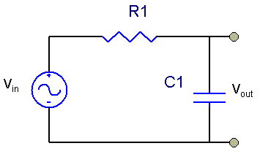

Put the Channel 1 probe of the Oscilloscope on the output of the FG (red one), with the Osc ground tied to the FG ground (black one).

Adjust the peak-to-peak voltage *v*s(t) of the FG to Vin(P-P) = 2 Volts, so Vin(Peak) = 1 Volts, and frequency f = 1kHz. (So, period Tp = 1/f = 1.0msec). Move it on the Osc to have it be a sinewave. Put it into the circuit as shown above.

Note: All AC voltages are with respect to the Osc & FG ground!

Use Channel 2 of the Osc to display and measure peak voltages at the top of the capacitor. The Osc can also display both peak voltage values and RMS voltage values. **For this lab, use peak voltages.**

For the frequencies listed in the first table below, calculate the capacitor impedance, total impedance, and output voltage phasor (magnitude and phase). Also measure, as shown.

ω = 2πf

**ZC = 1/jωC = -j/ωC**

**ZTotal** = R - j/ωC = **ZT/Φ1**

**VOutPeak) = Vin * [ZC/ZTotal] = VOut /-Φ1**

Note: To find angle /-Φ1, measure each time shift tx, and Tp

Then, calculate| /Φ1 | = (tx/Tp) x 3600

|  |  |  |  |  |
| --- | --- | --- | --- | --- |
| Frequency | 1 kHz | 5 kHz | 10 kHz | 50 kHz |
| **ZC** | -15915.49j | -3183.1j | -1591.54j | -318.31j |
| **ZTotal** | 16712.6∠-72.2 | 6011.8∠-32 | 5342.56∠-17.3 | 5109.9∠-3.57 |
| **ZC / ZTotal** | 0.952∠-17.76 | 0.529∠-58 | 0.298∠-72.7 | 0.062∠-86.43 |
| **VLoad (calculated)** | 0.952∠-17.76 | 0.529∠-58 | 0.298∠-72.7 | 0.062∠-86.43 |
| Tp = 1/f | 1ms | 200us | 100us | 20us |
| tx (measured) | 48us | 33us | 20us | -4.4us |
| /Φ1 | 17.28 | 59.4 | 72 | -79.2 |
| **VLoad (measured)** | 0.97V | 0.53V | 288mv | 61mv |



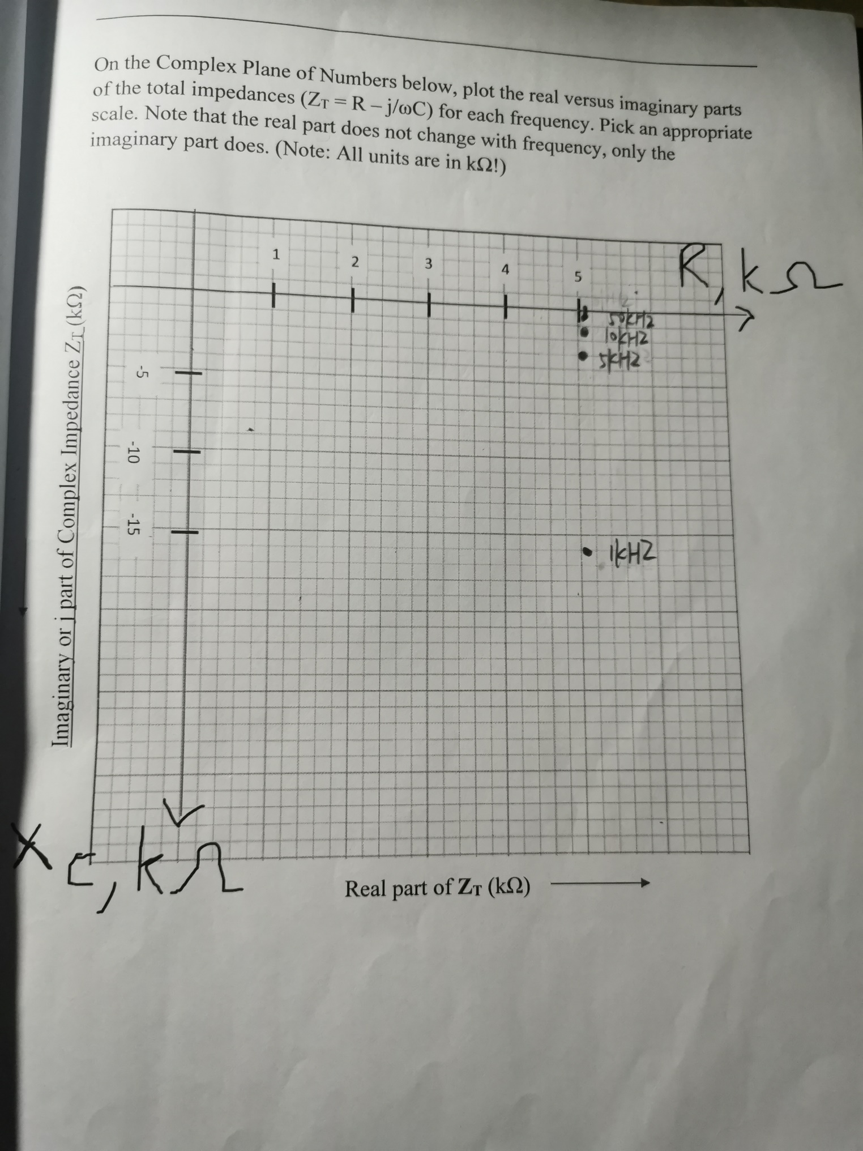

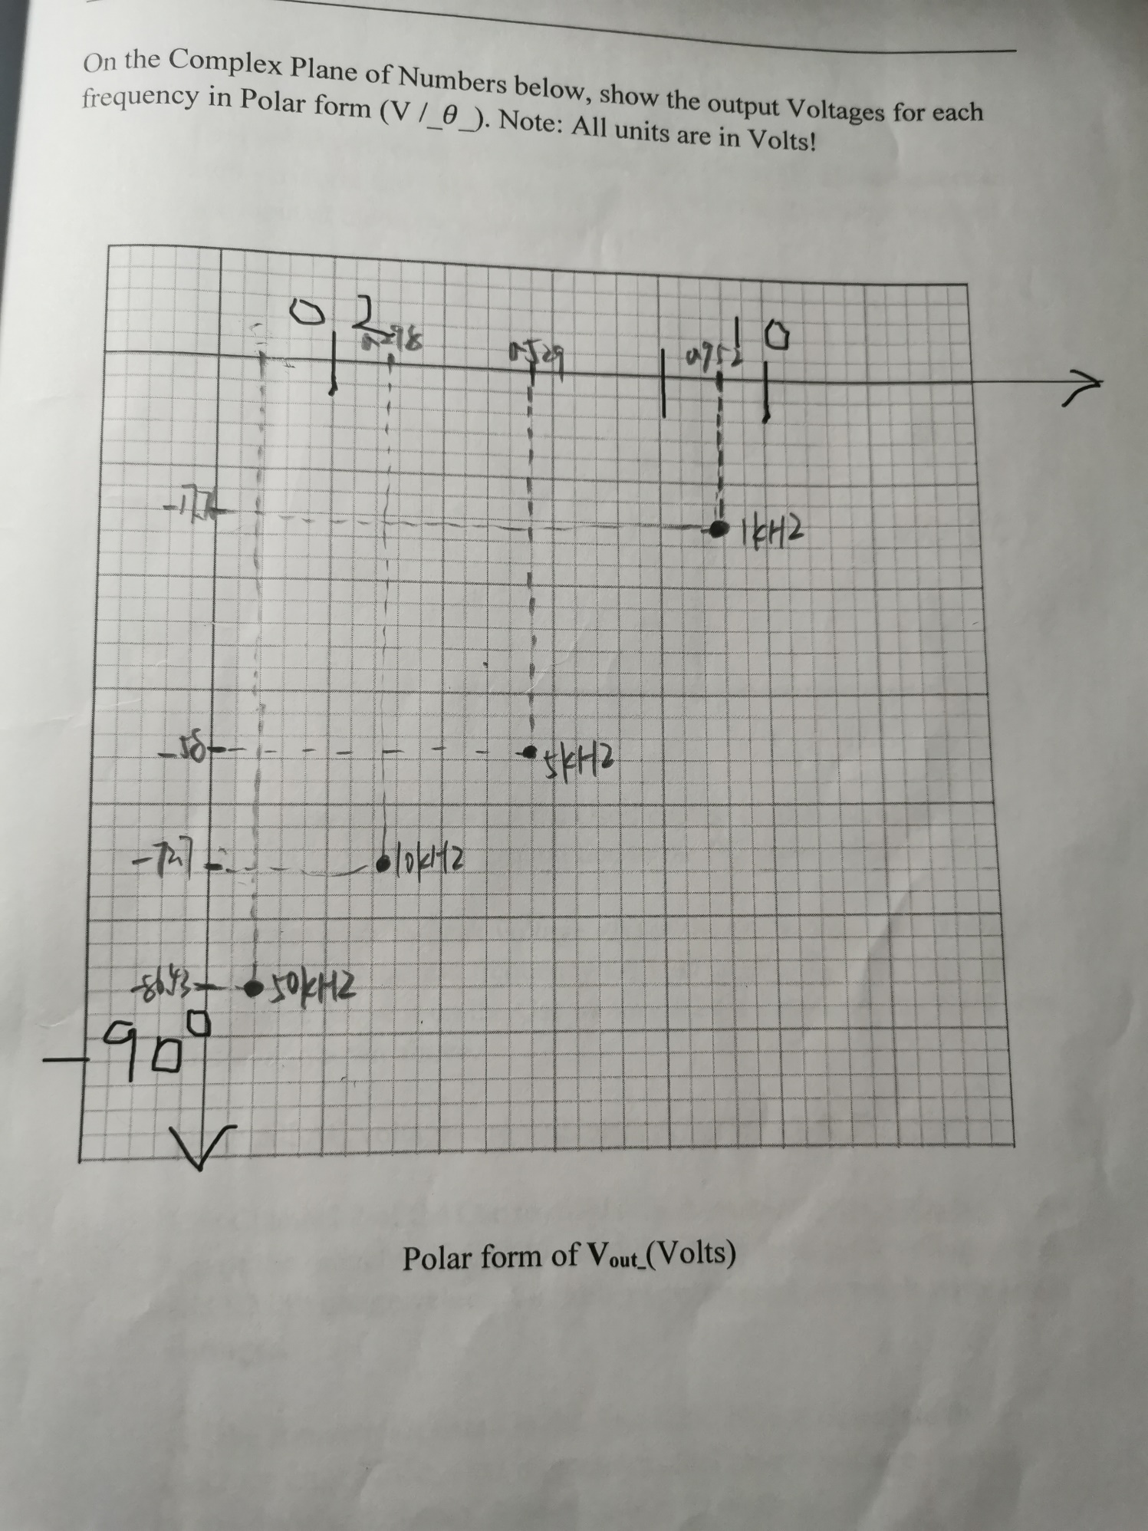

1. **RL circuit**

On the BB put resistor R2 in series with the **two 4.7 mH inductors in** series to form L = 9.4 mH and apply the FG voltage source, Vi(t), at the input at the in the schematic below.

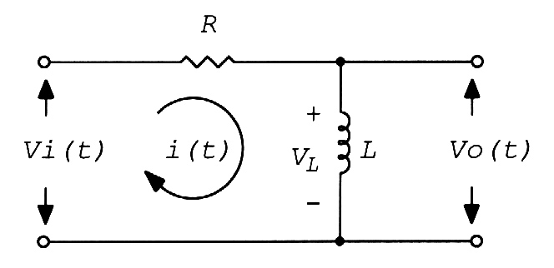

Put the Channel 1 probe of the Oscilloscope on the output of the FG (red one), with the Osc ground tied to the FG ground (black one).

Adjust the peak-to-peak voltage *v*i(t) of the FG to Vi(p-p) = 2 Volts, so Vin(Peak) = 1 Volts. and frequency f = 10kHz. (So, Tp = 1/f = 0.1 msec = 100 µsec). Move it on the Osc to have it be a sinewave. Put it into the circuit as shown above.

Note: All AC voltages are with respect to the Osc & FG ground!

Use Channel 2 of the Osc to display and measure peak voltages at the top of the inductor. The Osc can also display both peak voltage values and RMS voltage values. **For this experiment just work with peak voltages.**

For the frequencies listed in the first table below, calculate the inductor impedance, total impedance, and output voltage phasor (magnitude and phase). Also measure, as shown.

ω = 2πf

Tp = 1/f

**ZL = jωL**

**ZTotal =** R **+ jωL = ZT/Φ2**

**Vout(Peak) = Vin * [ZL/ZTotal] = Vout(Peak) /+Φ2**

Note: To find angle /-Φ2 measure each time shift: ty and Tp ;

then calculate /Φ2 = (ty/Tp) x 3600

|  |  |  |  |
| --- | --- | --- | --- |
| Frequency | 10 kHz | 50 kHz | 100 kHz |
| **ZL** | 590.619j | 2953.1j | 5906.2j |
| **ZTotal** | 5134.1∠6.6 | 5893.28∠30.1 | 7803.409∠49.19 |
| **ZL / ZTotal** | 0.115∠83.39 | 0.5∠59.93 | 0.757∠40.81 |
| **Vout (calculated)** | 0.115∠83.39 | 0.5∠59.93 | 0.757∠40.81 |
| Tp | 100us | 20us | 10us |
| ty (measured) | -20us | -3.2us | -920ns |
| /Φ2 | -72 | -57.6 | -33.2 |
| **Vout (measured)** | 112mv | 0.5v | 0.88v |

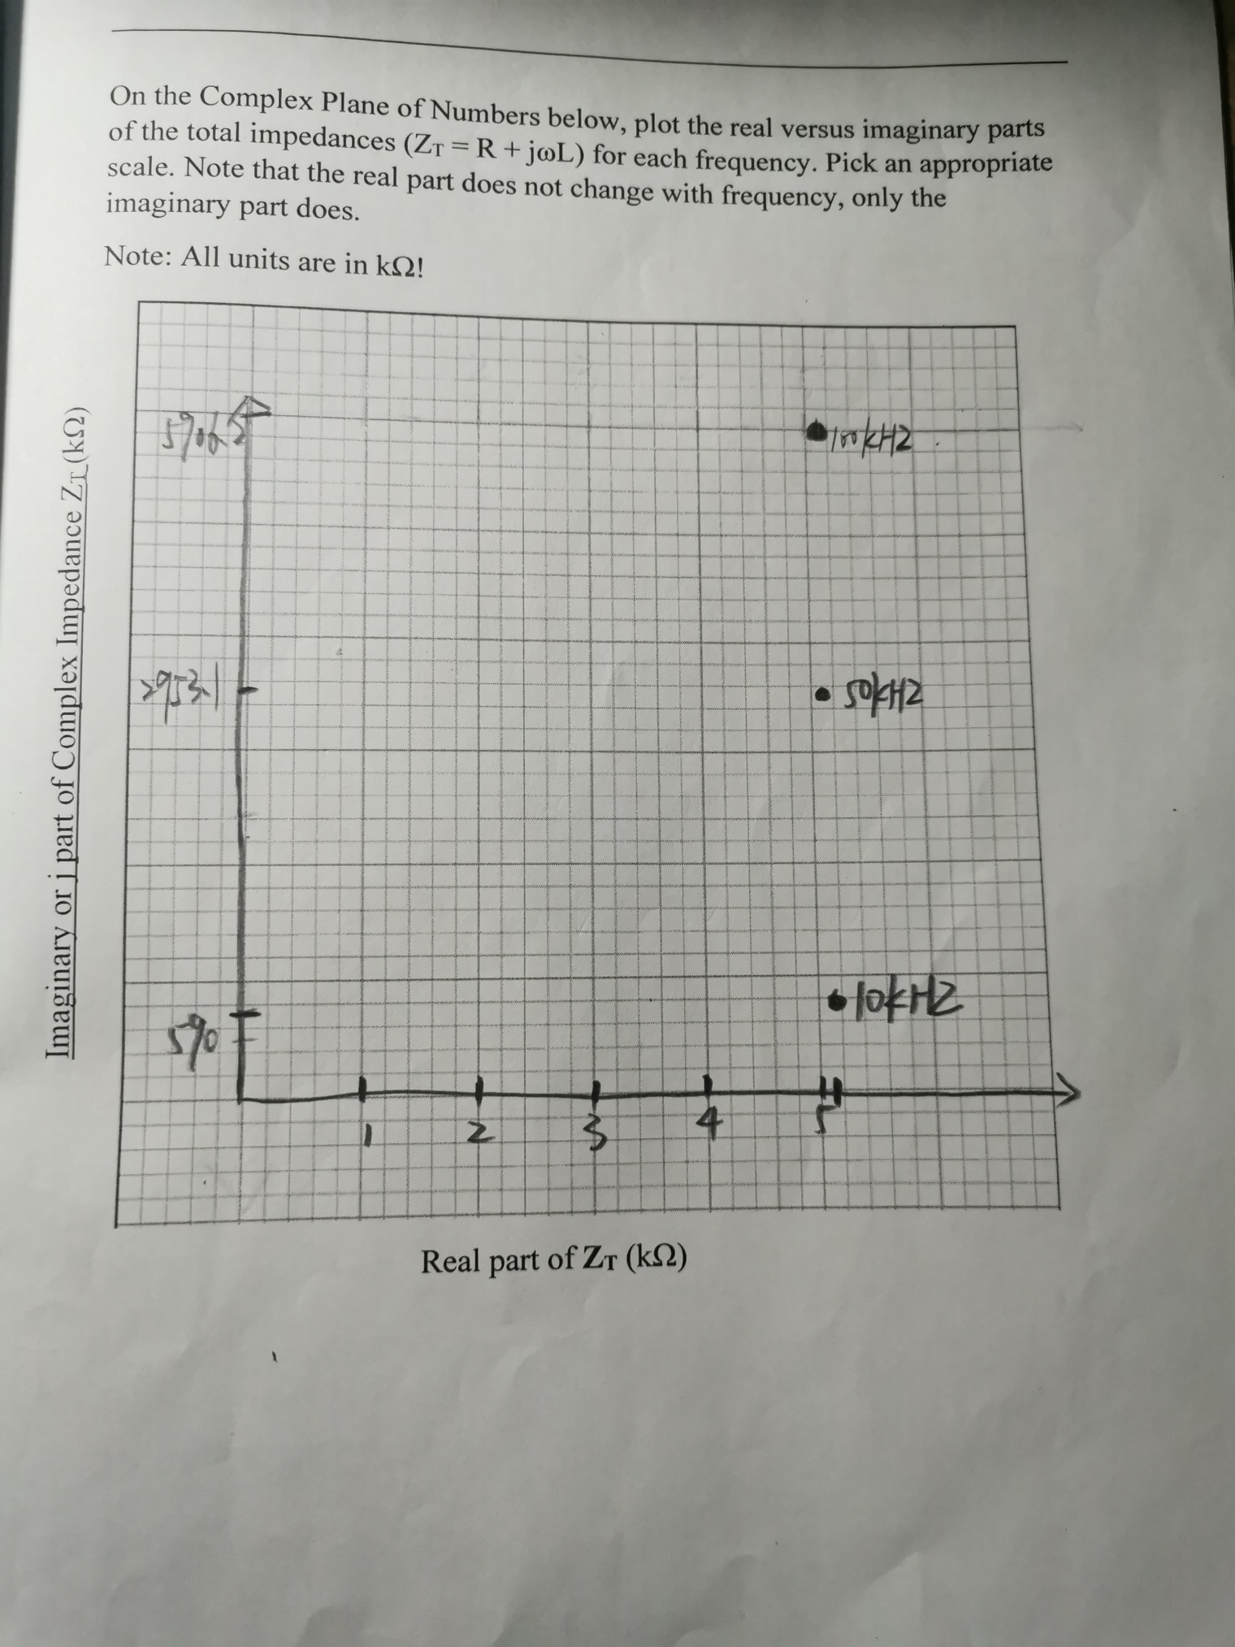

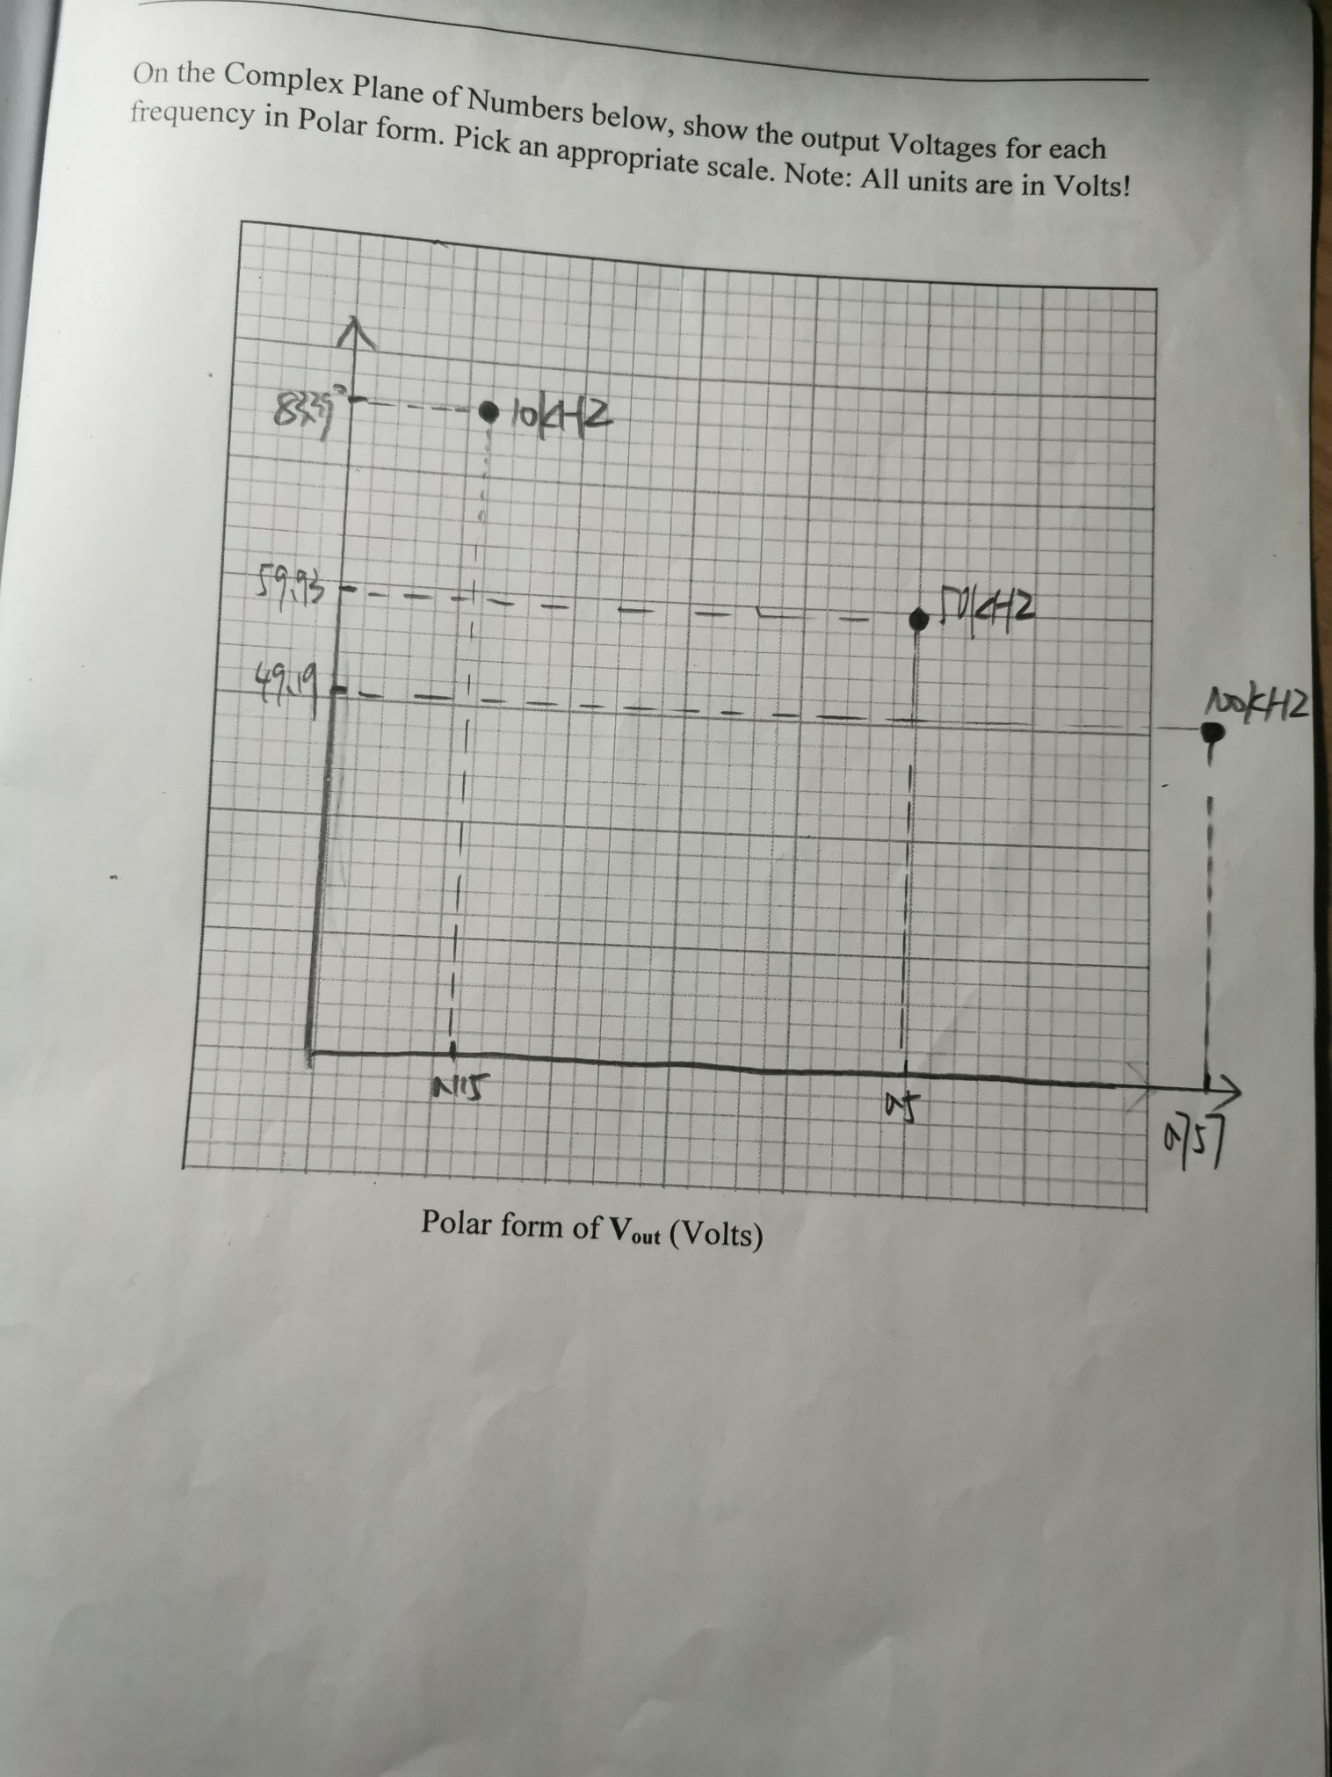

1. Questions
2. We have been using Ohm’s Law for resistors, V = IR. Now that we are including the concept of complex impedance, **Z/φz** , state Ohm’s Law in terms of Phasor Voltages, **V/φv**, Phasor Current, **I/φi** and Complex Impedance, **Z/φz** .

**Z/φz** = **V/φv**  / **I/φi**

1. How are the magnitudes of the three related mathematically? How are the phases of the three related mathematically? Explain clearly in your own words.

**Z is the ratio of V to. And in terms of phase, the phase of Z is the phase of V minus the phase of I**